# How to access data from SQL Server database in Win10 UWP

## Introduction

The Sample is upgraded from <https://code.msdn.microsoft.com/How-to-access-data-from-5f2602ec> for UWP.

Besides, the Sample demonstrates how to access data from SQL Server database in Windows10 UWP app. Please notice that we cannot directly access SQL Server Database from Windows 10 UWP app. Instead, we have to create a Service layer to access the database.

## Sample prerequisites

To open and run this sample, ensure that the following requisites has been met:

1. Microsoft Windows 10(10.0.14393) or above.
2. Microsoft Visual Studio 2015 Update3 or later version(s).
3. Microsoft Visual Studio installed UWP developer component.
4. Microsoft Visual Studio installed Web developer component.

## Building the sample

1. Open the sample solution “**CSUWPAccessSQLServer.sln**” using Visual Studio.
2. In Solution Explorer, right click project “**CSUWPAccessSQLServer**” and select **Set as StartUp Project**.

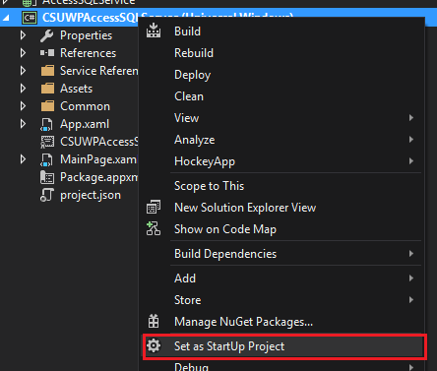

## Running the sample

* Open the sample solution using Visual studio, then press **F5 Key** or select **Debug -> Start Debugging** in menu.
* When the app is running, you can see this:

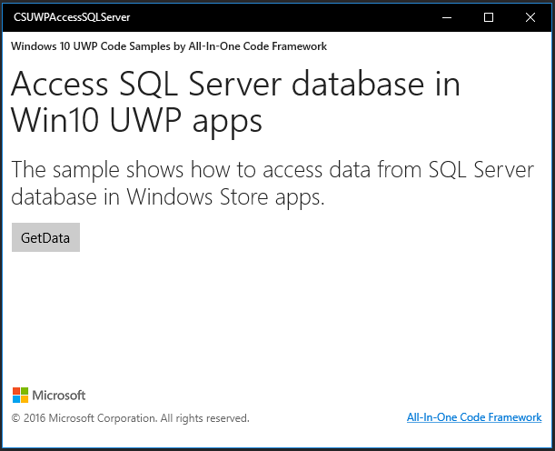

* Click the button GetData, the app will request to WCF service and get the data.

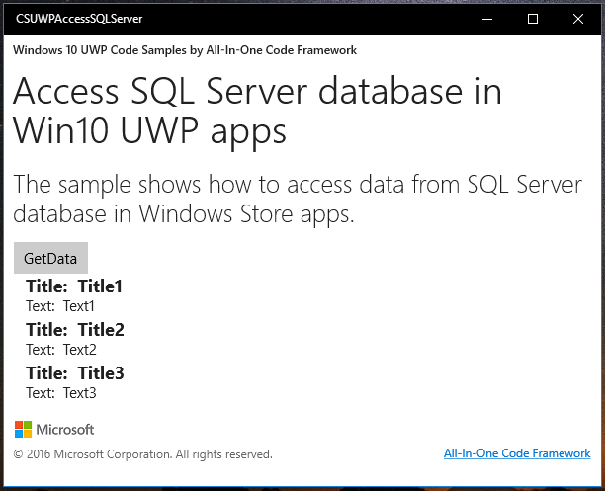

## Using the code

**In WCF Service**

Article.cs

[DataContract]

public class Article

{

[DataMember]

public string Title { get; set; }

[DataMember]

public string Text { get; set; }

}

IService.cs:

[ServiceContract]

public interface IService

{

[OperationContract]

IList<Article> QueryArticle();

}

Service.svc.cs

public IList<Article> QueryArticle()

{

DataSet ds = new DataSet();

using (SqlConnection sqlCon = new SqlConnection(SqlConStr))

{

try

{

sqlCon.Open();

string sqlStr = "select Title, Text from TestTable";

SqlDataAdapter sqlDa = new SqlDataAdapter(sqlStr, sqlCon);

sqlDa.Fill(ds);

}

catch

{

return null;

}

finally

{

sqlCon.Close();

}

}

List<Article> articleList = new List<Article>();

DataTable dt = ds.Tables[0];

foreach (DataRow dr in dt.Rows)

{

articleList.Add(new Article()

{

Title = dr["Title"] as string,

Text = dr["Text"] as string

});

}

return articleList;

}

**In UWP Client:**

MainPage.xaml.cs

private async void GetButton_Click(object sender, RoutedEventArgs e)

{

ServiceClient client = new ServiceClient();

IList<Article> articleList = await client.QueryArticleAsync();

//set the result to UI

lvDataTemplates.ItemsSource = articleList;

}

## More information

Win8.1 Version: <https://code.msdn.microsoft.com/How-to-access-data-from-5f2602ec>